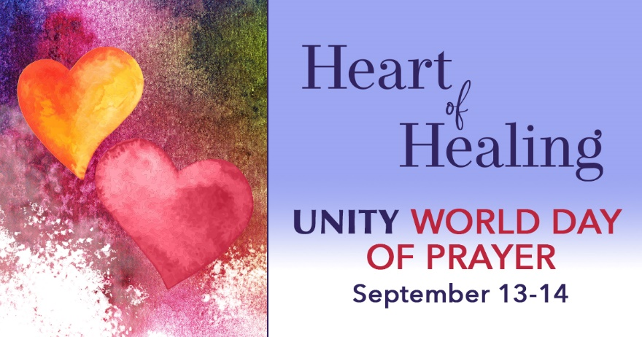

Wednesday, September 13 at 6 p.m.
Opening Ceremony with
Reverend Taylor Stevens

Thursday September 14 at 11:15 a.m.
Heart of Healing Prayer
with Reverend Taylor Stevens

Thursday September 14 at 6 p.m.
Closing Ceremony: The Truth of Wholeness
With Reverend Taylor Stevens

Contact the office for Zoom Code

Wednesday, September 13 at 6 p.m.
Opening Ceremony with
Reverend Taylor Stevens

Thursday September 14 at 11:15 a.m.
Heart of Healing Prayer with
Reverend Taylor Stevens

Thursday September 14 at 6 p.m.
Closing Ceremony: The Truth of Wholeness
With Reverend Taylor Stevens

Contact the office for Zoom Code

